WEEK 3 DAY 3
TASK 3

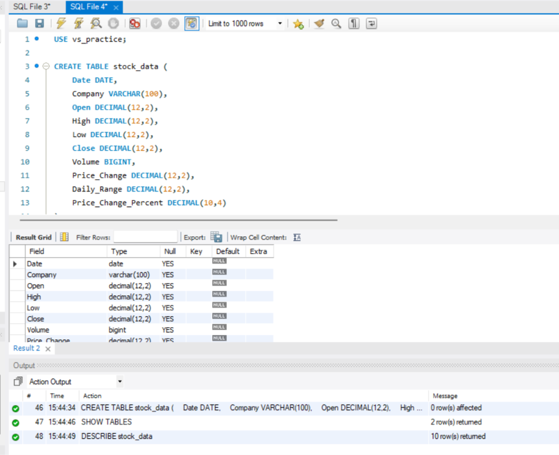

Query 1: Display all stock records
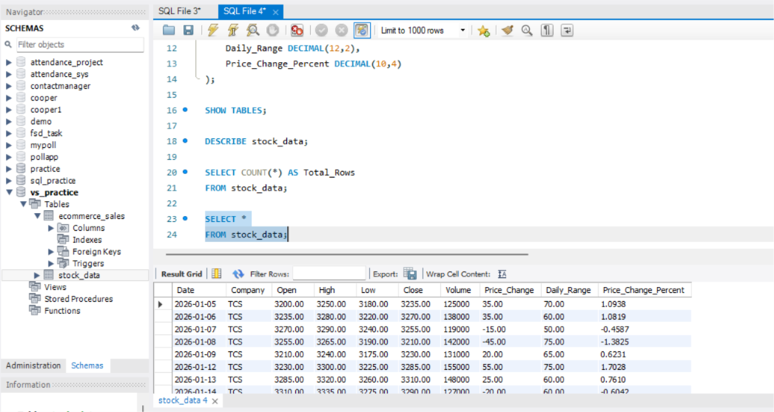

Query 2: Find records where the closing price is above 3300
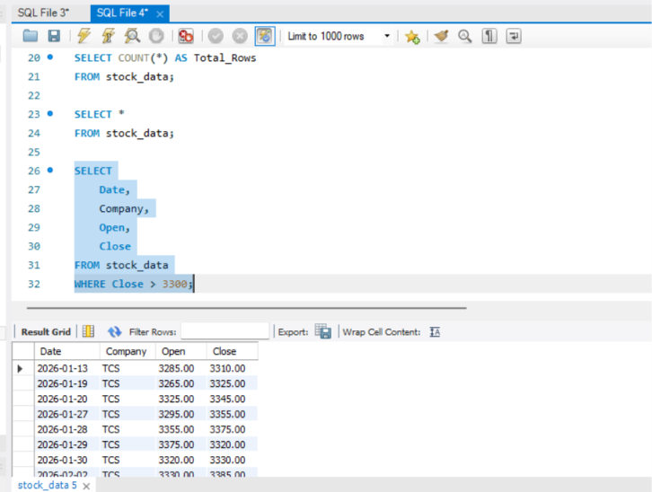
Query 3: Find the top 5 highest closing prices
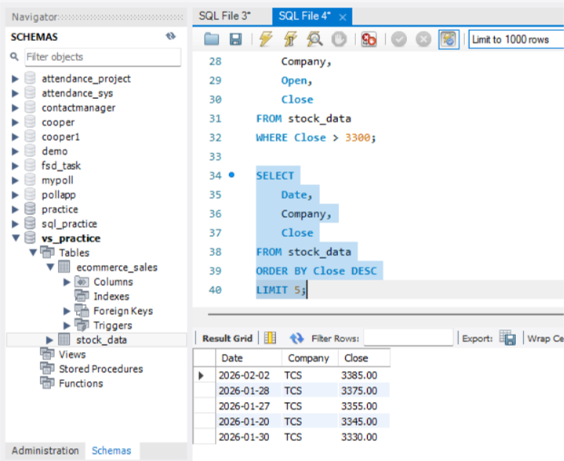
Query 4: Calculate average, maximum and minimum closing prices
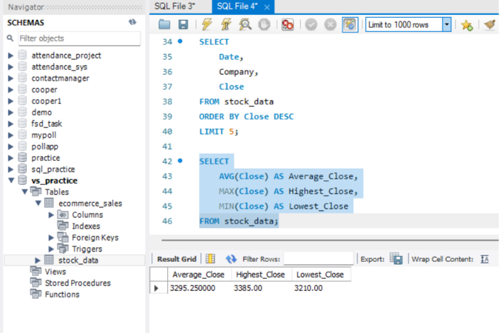

Query 5: Analyze daily trading volume
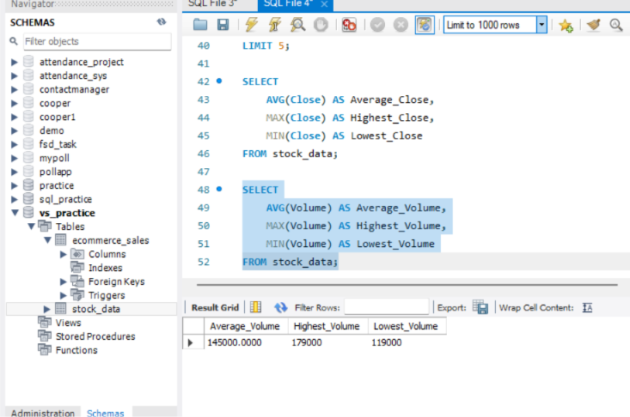

Query 6: Count days when the stock increased or decreased
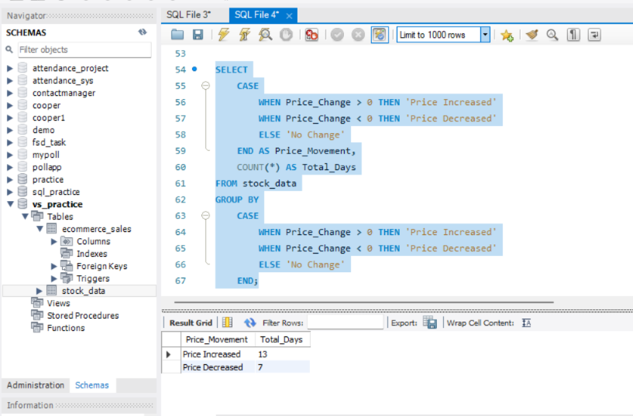

Query 7: Find days with above-average percentage price changes
